https://ftp.rush.edu/users/molebio/MOLDICE/Moldice%20Solicitation.mht

https://www.fbo.gov/index?s=opportunity&mode=form&tab=core&id=40af16ef8390603c1adb23ec5a4315dc&_cvie

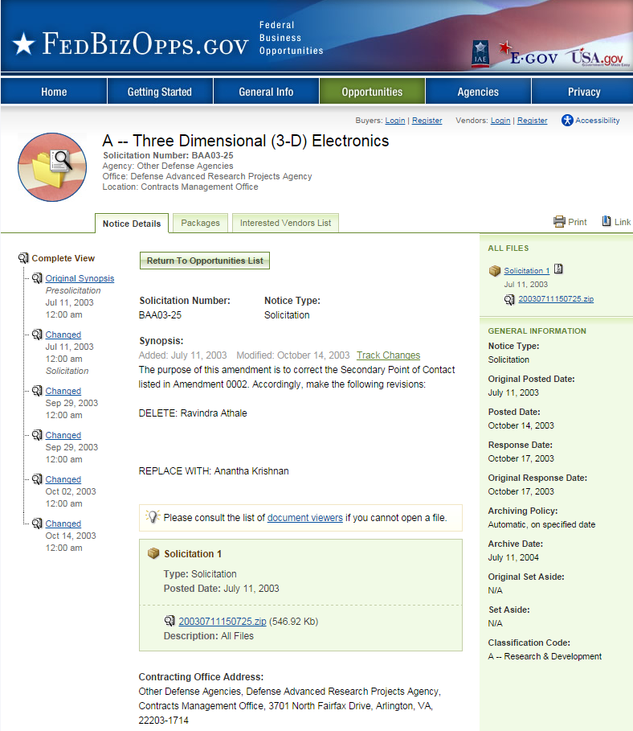

Subject: The Defense Advanced Research Projects Agency
Date: Sat, 2 Nov 2002 12:43:05 -0600 MIME-Version: 1.0
Content-Type: multipart/related;
Produced By Microsoft MimeOLE V6.00.2800.1106
This is a multi-part message in MIME format.
Content-Transfer-Encoding: quoted-printable
Content-Location: http://www.darpa.mil/baa/baa01-42mod17.htm
The Defense Advanced Research Projects Agency
3DGENERATOR official FedBizOpps announcement takes precedence over this
in any disagreement between the two. provided for your convenience only

General Information Modification to a Previous Presolicitation
Contracting Office Address Other Defense Agencies,
Defense Advanced Research Projects Contracts Management Office, 3701 North Fairfax DriveArlington, VA 22203-1714

BAA 01-42, ADDENDUM NO. 12,
SPECIAL FOCUS AREA: ENGINEERED
BIO-MOLECULAR NANO-DEVICES/SYSTEMS (MOLDICE)

The Defense Sciences Office is interested in receiving proposals for innovative research on the development and demonstration of novel hybrid (biotic-abiotic)nanoscale interface technologies that enable direct, real-time conversion of bio-molecular signals into electrical signals. Biological systems exhibit remarkable sensitivity,selectivity and efficiency that could be exploited in engineering systems should appropriate interfaces become available.

Biological systems have well defined sensing units signal processing units and actuation sub-systems that determine responses to specific stimuli. While significant effort has gone into understanding the sensing systems of biology (e.g., receptor and transmembrane proteins), the intra-cellular signal processing system is still the subject of many ongoing research efforts. The objective of this research is to develop hybrid bio-molecular devices/systems that use biological units (e.g., Protein Ion Channels/Nanopores,G-Protein Coupled Receptors, etc.) for performing the sensing function but use silicon circuitry to accomplish the signal processing. Innovative ideas are needed for the development of interfaces (to ion channels and receptors) that enable the real-time (temporal) transduction of molecular (stochastic) events into electrical signals.

A critical focus of this program is the exploitation of temporal (kinetic) information for the real-time analysis and detection of molecular targets. This research will lay the foundation for advanced?biology-to-digital? converter systems that enable direct, real-time conversion of biological signals into digital information. Ongoing research in nanotechnology is starting to demonstrate controlled fabrication of high quality nanostructures (nanoparticles, nanotubes, nanopores, etc.) that are capable of interacting with biology at the molecular scale.

Significant recent accomplishments in biology and surface chemistry have also demonstrated programmed assembly of engineered molecular structures with excellent control on spatial distribution and orientation. It is anticipated that these developments will lead to new kinds of nanoscale bio-electronic interface technologies extendible to array platforms that enable combinatorial, dynamic (real-time) sampling of stochastic signals
from individual bio-molecular receptors in order to develop unique bio-signatures for various target molecules of interest.

Examples of potential bio-molecular devices (that perform bio-electronic transduction at the nanoscale) include protein ion channels that have been demonstrated to be highly sensitive detectors of molecular events.

MOLDICE is a two-phase program addressing the above ideas and concepts. The main goal of the Phase I effort is to demonstrate novel and innovative hybrid bio-molecular device architectures that are scalable to 2D array platforms. Phase 1 will explore techniques to assemble bio-molecular sensing devices (e.g., engineered protein ion channels/receptors) on a substrate with appropriate interface technologies to couple to silicon circuitry.

The Phase I effort will also investigate and demonstrate novel methods to electrically address these bio-molecules at the nanoscale. Issues such as device orientation, spatial distribution, materials compatibility/robustness,signal-to-noise ratio (SNR), ability to scale-up (to arrays),signal bandwidth and temporal resolution, etc. will be addressed during this phase. A key Phase I milestone will be the measurement and validation of electrical signals (bio-signatures) for various target molecules of interest. Phase 2 will focus on scale-up of the Phase I device architectures into array platforms with large-scale integration and parallelization.

An important component of the Phase II effort will be the signal processing task associated with array processing of stochastic signals from individual bio-molecular sensing devices. Additionally, Phase II will demonstrate operation and controllability of devices and systems and quantify performance metrics for the array platform (sensitivity, selectivity, speed, efficiency and power consumption) in the context of various sensing schemes. Proposals should be phased. Phase I should not exceed eighteen (18) months, with Phase II not exceeding thirty (30) months.

All milestones are considered as "go/no-go" decision points. If multiple awards are made, down-selection may occur at the end of each Phase. Proposals in response to this addendum should describe an 18-month Phase 1 program. Proposers may submit an optional Phase II proposal for a 24-30 month effort, however, selections will be made on the basis of the Phase I effort only.

Proposers for Phase 1 should consider research efforts that address one or more of the following technical areas: (1) Signal Acquisition and Transduction : Investigate the exploitation of the temporal domain (i.e., kinetics) to develop unique bio-signatures for various molecules of interest to the biological/chemical sensing community. Determine the nature of signals that need to be extracted from hybrid bio-molecular devices and the information content in these signals.

Explore engineering of bio-molecular devices to provide specific signals of interest. Study and quantify acquisition, filtering, amplification and temporal resolution of the signal from the hybrid bio-molecular device. (2) Electronic Addressability at the Molecular Scale: Investigate novel and innovative technologies to enable single molecule addressability at the nanoscale for high SNR (Signal-to-Noise Ratio) transduction of the signals for further processing in silicon. Develop novel interface technologies to ultimately convert these signals into real-time electrical signals. Investigate novel materials and assembly/integration technologies to ensure robust and reliable device operation.

Progress in this program will depend on the formation of well-managed interdisciplinary efforts drawing on expertise from such areas as molecular biology, bio-chemistry, electrical engineering, materials science, applied mathematics, computer science and micro/nano-fabrication.

In addition, it is expected that a strong modeling component will be included wherever necessary. Regardless of the interdisciplinary composition of the team, its members will need to be sharply and collectively focused on achieving the Phase 1 objectives. A limited number of smaller efforts focused on developing unique approaches to overcoming specific technology challenges may be supported with an eye towards incorporating them into the integrated team efforts by the end of the program.

DARPA invites white papers (10 pages or less)in response to this announcement. The white paper should be organized as follows: 1) Description of the Idea: What specific capabilities are being proposed? What is novel about this idea and why is it better (and by how much?) as compared to current state-of-the-art? 2) The Planned Approach: How will the proposed capabilities be demonstrated within the 18 month period of funding? What are the research challenges and milestones, and how will these be addressed? Every white paper must describe the 18-month quantitative milestone(s) that will be achieved in order to meet the Phase I objectives; 3) The Cost: What is the cost estimate for resources required for the proposed time line? This section should include a clear description of the human resources and equipment(if any), and appropriate justification for these resources/costs; and 4) The Team: A brief description of the technical expertise of the principal investigator and the key team members should be provided. The management plan should describe how the different disciplines represented on the team would be integrated to generate a capability demonstration within 18 months.

A designated website http://www.darpa.mil/leaving.asp?url=3Dhttp://teaming.sysplan.com=
/MOLDICE/">http://www.darpa.mil/leaving.asp?url=3Dhttp://teaming.sysplan.=
com/MOLDICE/ is being made available to assist in the teaming process.

While there is no formal date for submission, white papers sent within 30 days of publication of this Addendum will be evaluated immediately upon receipt and proposers will be notified within 10 business days of receipt as to whether or not a full proposal submission is recommended. White papers submitted after the 30-day time period will be considered on a case-by-case basis.

White paper submissions may be made by attachment to an e-mail sent to:dsobaa01-42@darpa.mil
Word 97 or higher is recommended but not required. Embedded text and Postscript are also acceptable. Please put "Engineered Bio-Molecular Nano-Devices/Systems MOLDICE)" in the subject of the e-mail. The body of the e-mail must include name, mailing address, phone number, and fax number.

If submitting by U.S. mail, the proposers must submit an original and five (5) copies of the white paper to DARPA/DSO,ATTN: Engineered Bio-Molecular Nano-Devices/Systems (MOLDICE), BAA 01-42, Addendum 12, 3701 North Fairfax Drive, Arlington, VA 22203-1714.

Notwithstanding the disposition of white papers, DARPA will respond to full proposals expeditiously, upon scientific review, with the first wave of proposals being reviewed within 90 days after publication ofthis addendum. Regardless of the recommendation based on the white paper, the decision to submit a full proposal is the responsibility of the proposer. White papers and proposals will not be accepted by way of facsimile transmission. For general administrative questions and instructions regarding submission of proposals, please refer to the original CBD announcement, BAA 01-42, of September 4, 2001. No full proposals will be considered if received after 4:00 PM Eastern Time on the date BAA 01-42 closes.

Point of Contact: Anantha Krishnan,DARPA
Program Manager,
Phone: 703-696-4470, Fax: 571-218-4553,
Email: akrishnan@darpa.mil

Original Point of Contact Steven Wax,
Deputy Director, Defense Sciences Office,
Phone 703-696-2281, Fax 703-696-3999,

Current Point of Contact Steven Wax,
Deputy Director, Defense Sciences Office,
Phone 703-696-2281, Fax 703-696-3999

